Create Maven Project

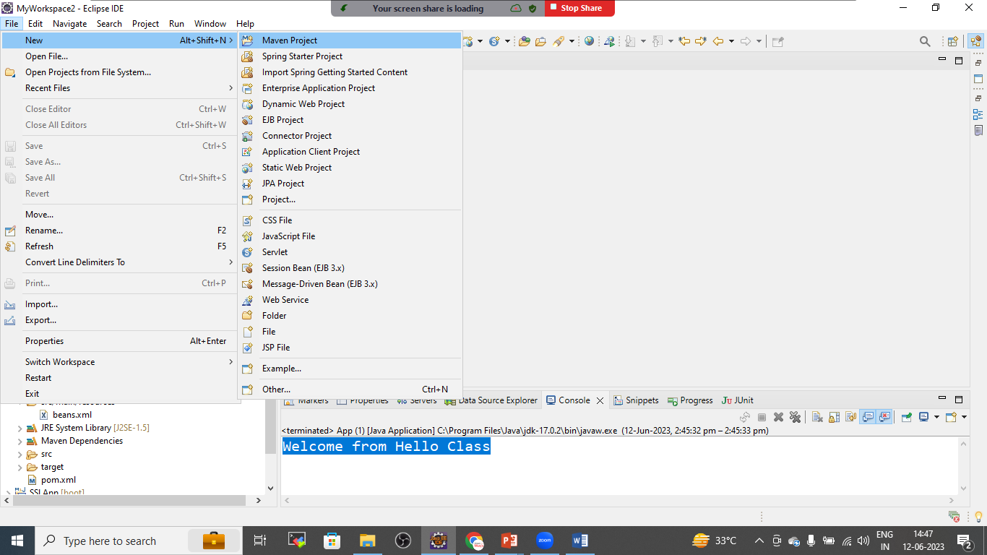

Click on NEXT

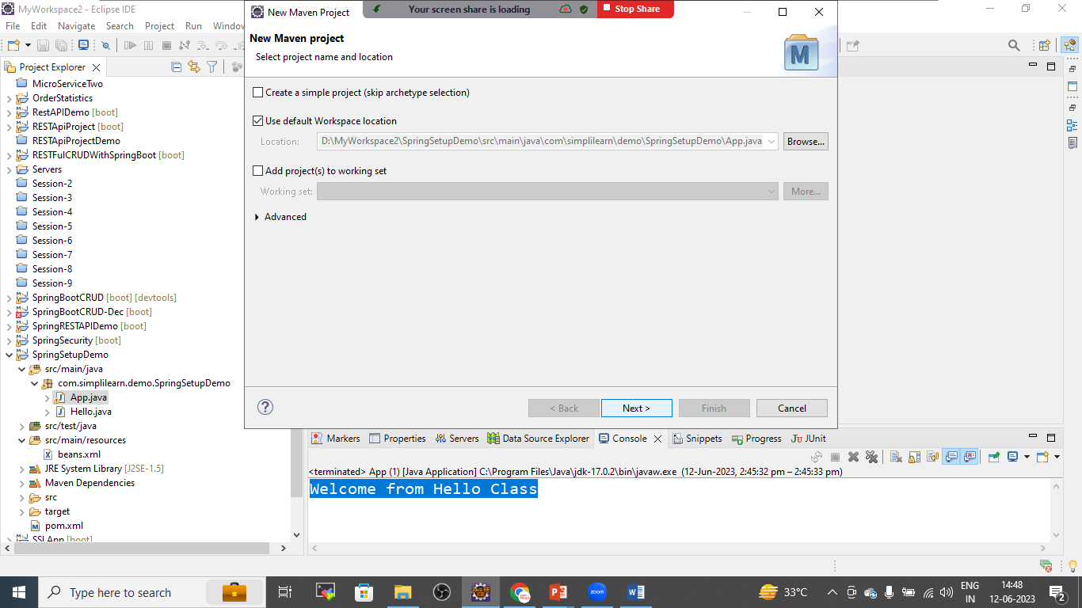

CHOOSE CATALOGE AS :INTERNAL AND SELECT QUICK START APP CLICK NEXT

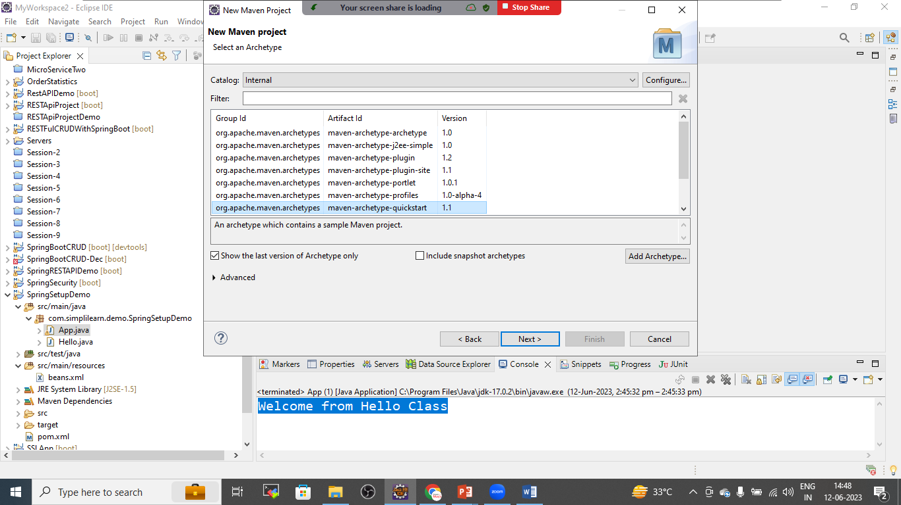

PROVIDE PROJECT NAME IN ARTIFACT ID:

Make sure that Group Id and Package name must be same

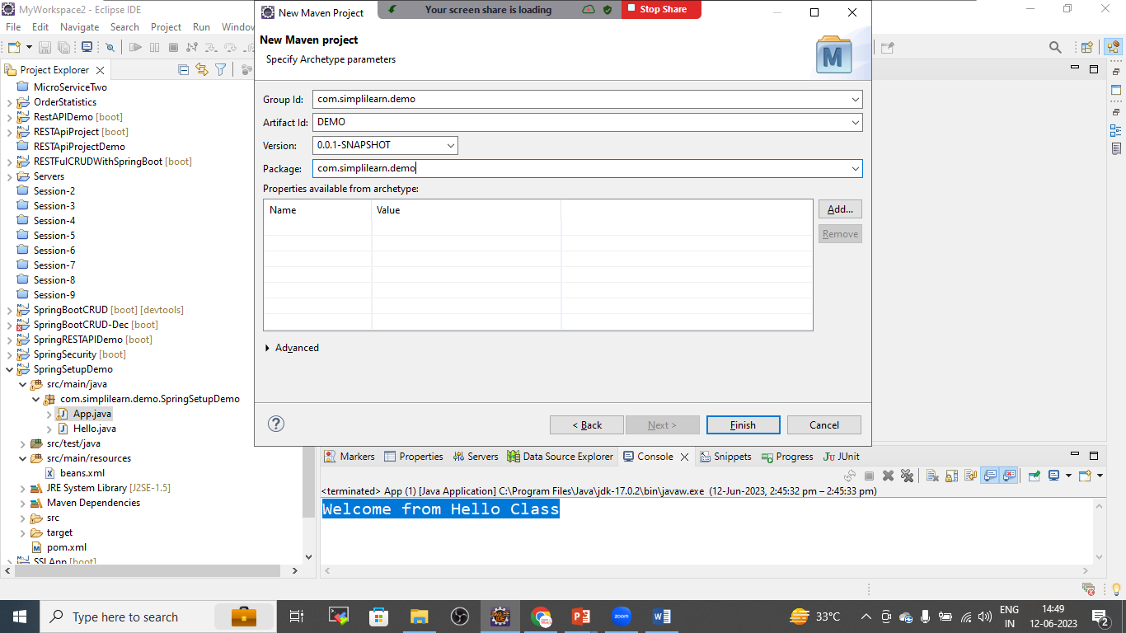

Open pom.xml File

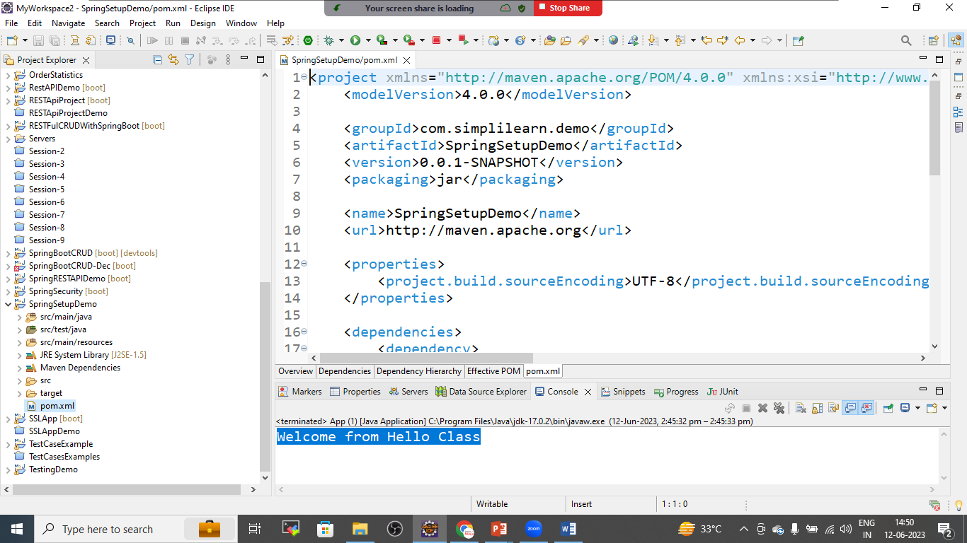

Now add the below dependencies from Maven repository

<!--Spring Core-->

<dependency>

<groupId>org.springframework</groupId>

<artifactId>spring-core</artifactId>

<version>6.0.9</version>

</dependency>

<!--Spring Context-->

<dependency>

<groupId>org.springframework</groupId>

<artifactId>spring-context</artifactId>

<version>6.0.9</version>

</dependency>

<!--Spring beans-->

<dependency>

<groupId>org.springframework</groupId>

<artifactId>spring-beans</artifactId>

<version>6.0.9</version>

</dependency>

<!--press ctr+shift+F-->

After adding the dependencies

Right Click on project >maven>update the project

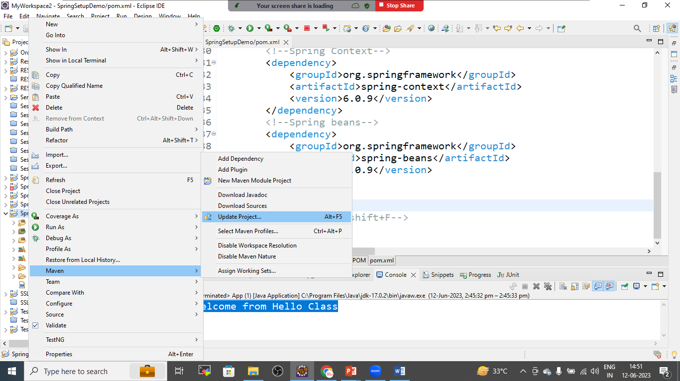

Prepare java class as below

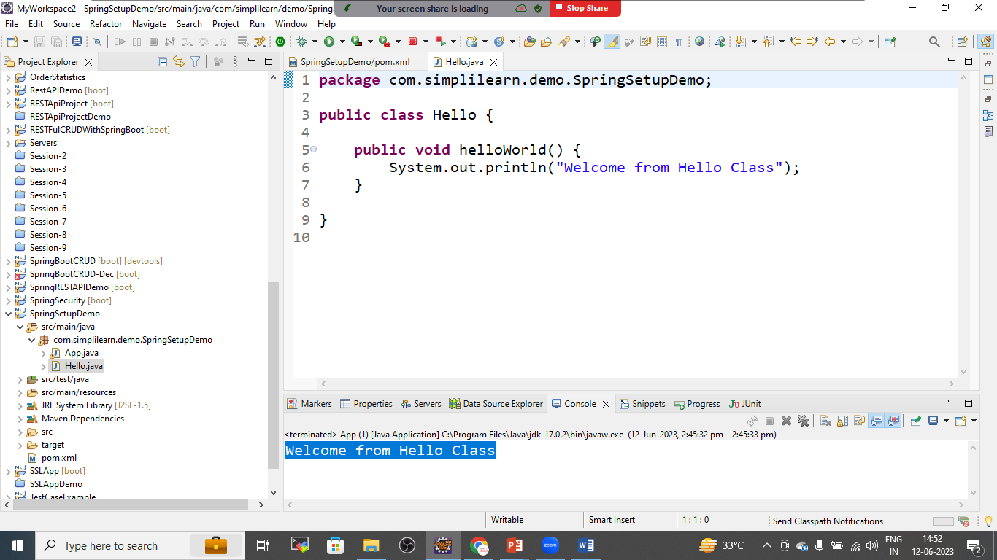

Hello.java

**package** com.simplilearn.demo.SpringSetupDemo;

**public** **class** Hello {

**public** **void** helloWorld() {

System.out.println("Welcome from Hello Class");

}

}

Right click on project >new>resource folder

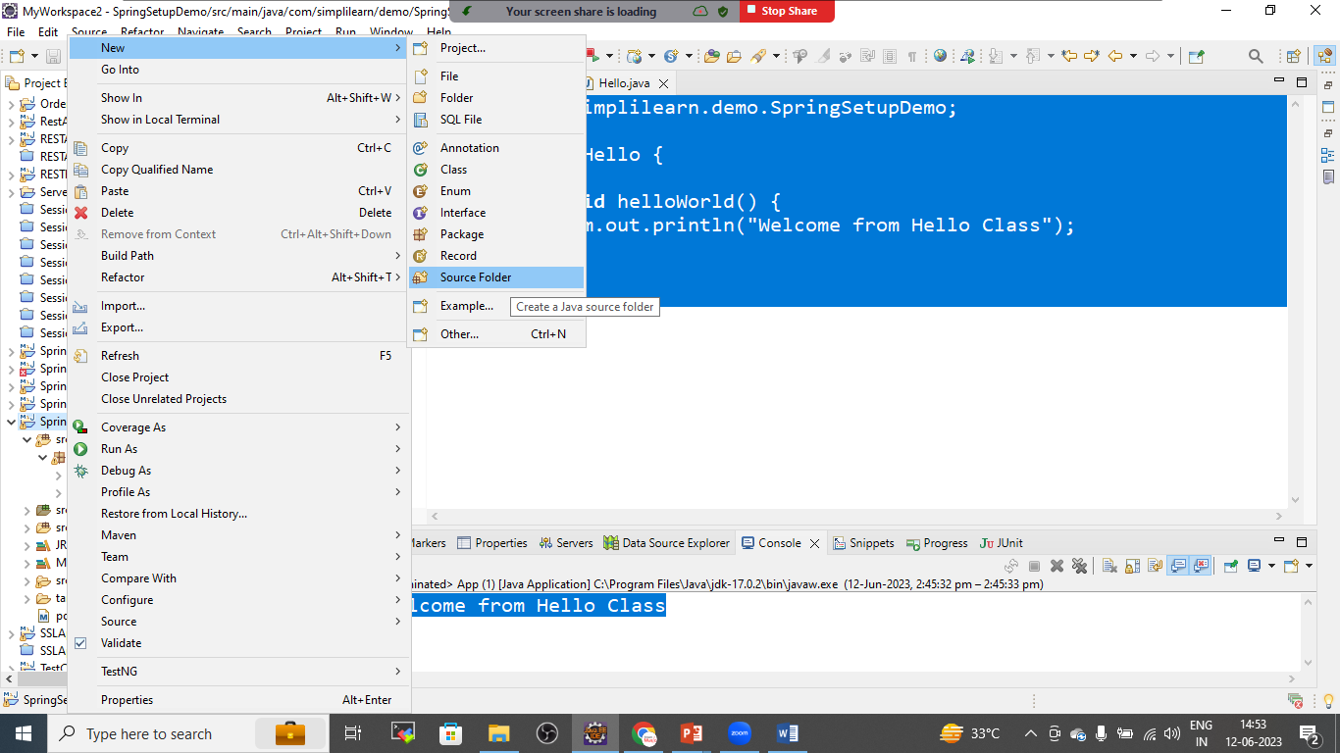

Give the name

Src/main/resources

Then click on next

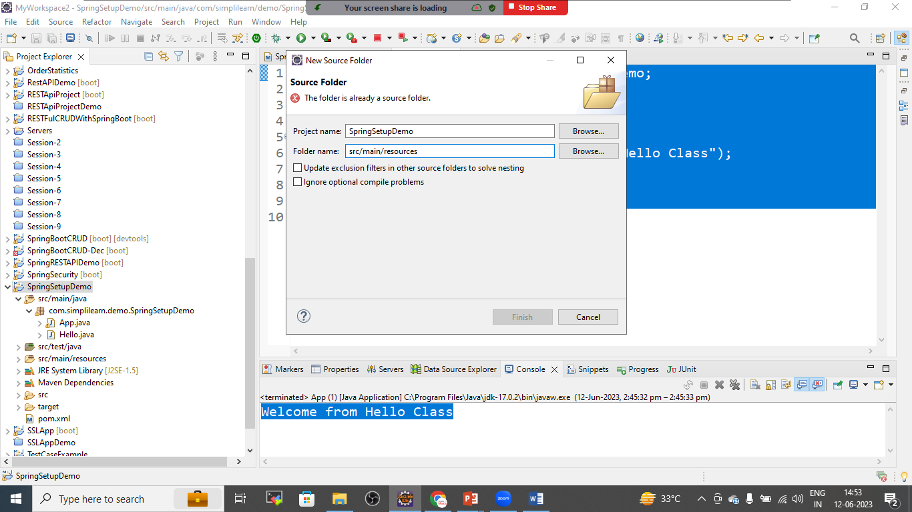

Right click on resource folder>new>others>xml

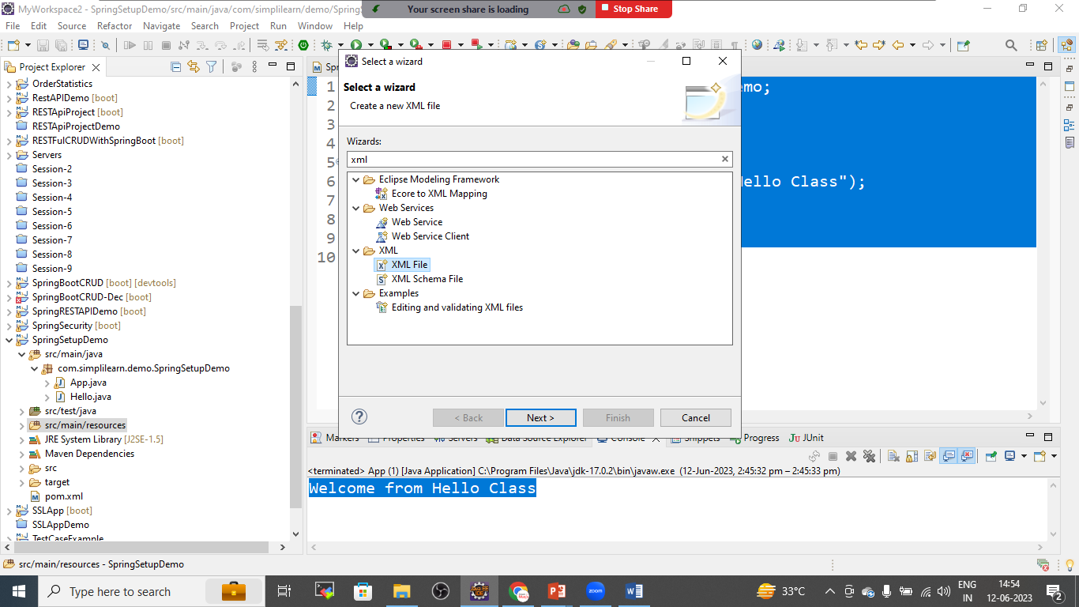give the name as beans.xml

Beans.xml

<?xml version=*"1.0"* encoding=*"UTF-8"*?>

<beans xmlns=*"http://www.springframework.org/schema/beans"*

xmlns:xsi=*"http://www.w3.org/2001/XMLSchema-instance"*

xsi:schemaLocation=*"*

*http://www.springframework.org/schema/beans http://www.springframework.org/schema/beans/spring-beans.xsd"*>

<!-- bean definitions here -->

<bean id=*"h"* class=*"com.simplilearn.demo.SpringSetupDemo.Hello"*></bean>

<!-- download the dtd or xsd file from link: https://docs.spring.io/spring-framework/docs/4.2.x/spring-framework-reference/html/xsd-configuration.html -->

</beans>

Goto app.java

package com.simplilearn.demo.SpringSetupDemo;

import org.springframework.beans.factory.BeanFactory;

import org.springframework.context.ApplicationContext;

import org.springframework.context.support.ClassPathXmlApplicationContext;

import org.springframework.core.io.ClassPathResource;

import org.springframework.core.io.Resource;

public class App

{

public static void main( String[] args )

{

//Resource resource= new ClassPathResource("beans.xml");

//BeanFactory factory= new XmlBeanFactory(resource);

ApplicationContext context= new ClassPathXmlApplicationContext("beans.xml");

Hello hello= (Hello) context.getBean("h");

hello.helloWorld();

}

}

Save all the files and run the project as java application

Output:

